Type Of Software Testing
- Unit Testing
Definition:
Unit testing is the process of testing individual components or modules of a software application in isolation. It focuses on small, specific parts of the application, such as functions or methods.
Purpose:
To validate that each unit of the software performs as expected.
Key Considerations:
- Typically, automated.
- Written by developers during the coding phase.
- Helps catch bugs early in the development cycle.

Open unittesting.png
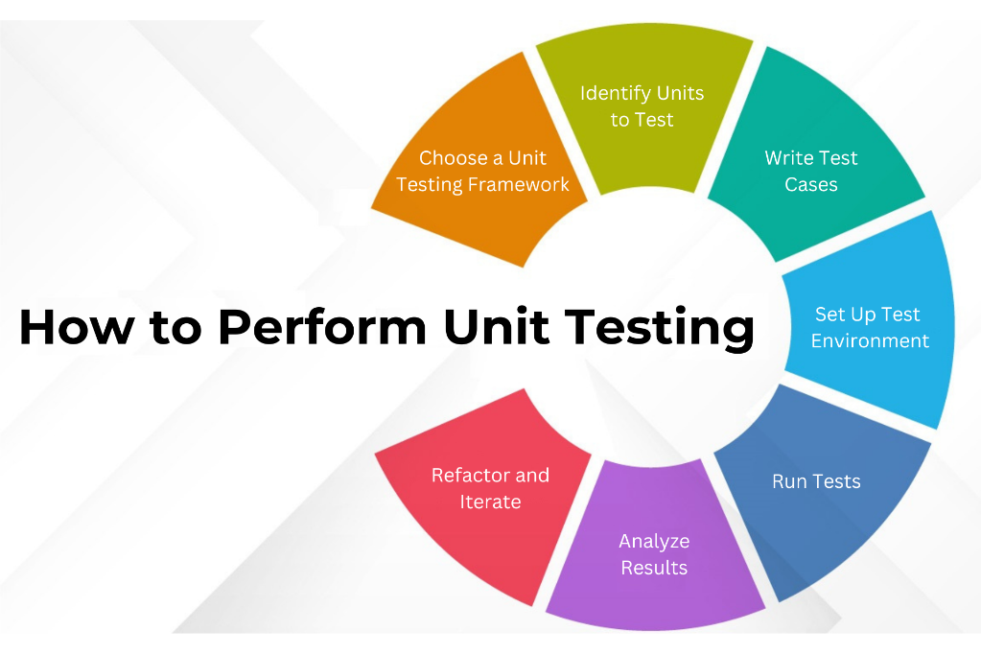
- Integration Testing
Definition:
Integration testing checks the interfaces and interactions between integrated units or components. It ensures that combined parts of the application work together properly.
Purpose:
To detect interface defects between modules.
Key Considerations:
- Can be performed incrementally (incremental integration testing) or all at once (big bang integration testing).
- Focuses on data flow and control flow between modules.

Open Integration_testing.png
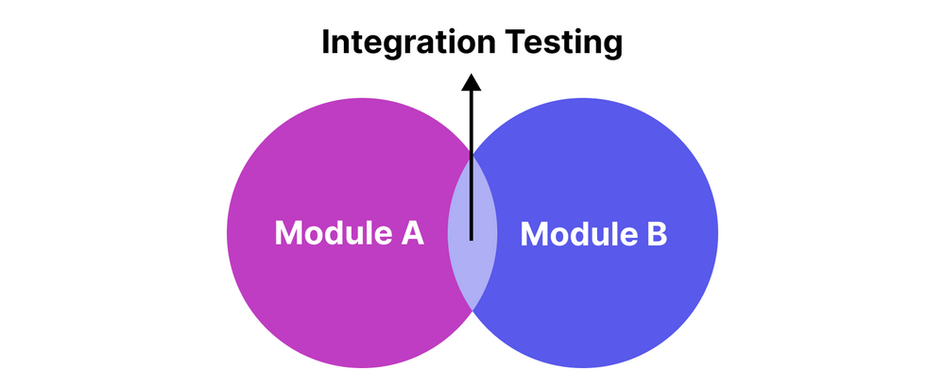

- System Testing
Definition:
System testing involves testing the complete and integrated software system as a whole. It validates the system against the specified requirements.
Purpose:
To ensure the software meets functional and non-functional requirements.
Key Considerations:
- Performed in an environment that closely resembles production.
- May include different types of testing, such as performance and security testing.

Open system_testing.png
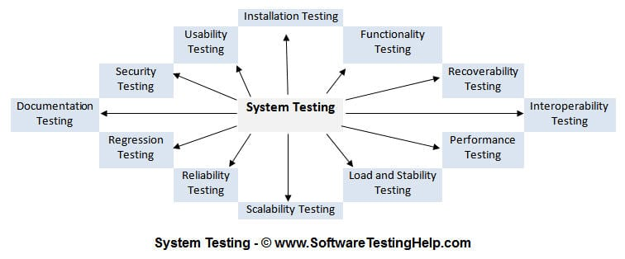
- Acceptance Testing
Definition:
Acceptance testing is conducted to determine whether a system meets the acceptance criteria and is ready for delivery to end users. This type often involves end users or stakeholders.
Purpose:
To validate the software’s usability, functionality, and compliance with business requirements.
Key Considerations:
- Can be categorized into user acceptance testing (UAT) and operational acceptance testing (OAT).
- Usually performed in the final phase of testing.

Open uat_testing.png
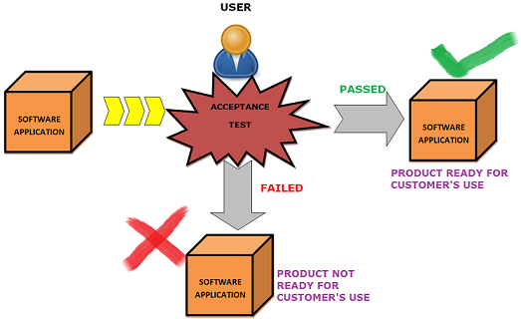

- Functional Testing
Definition:
Functional testing verifies that the software performs its intended functions according to the specified requirements.
Purpose:
To ensure that all functionalities work as expected.
Key Considerations:
- Involves testing user interactions with the application.
- Can be done manually or automated, with a focus on the output of functions.
Open functional-testing.png
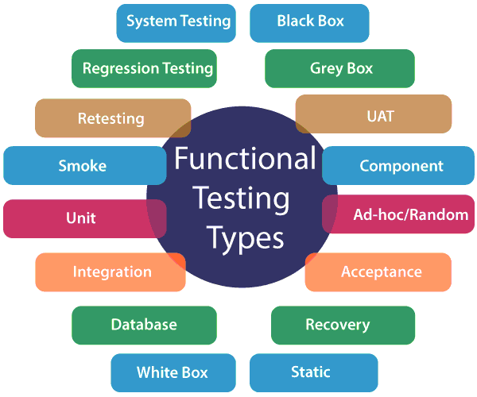

- Non-Functional Testing
Definition:
Non-functional testing evaluates aspects of the software that do not relate to specific behaviors or functions. This includes performance, usability, reliability, etc.
Purpose:
To assess the system's performance under various conditions and its overall user experience.
- Key Considerations:
- Includes sub-types like performance testing, load testing, and stress testing.
- Helps in understanding how the system behaves under load and its usability metrics.

Open non-functional.png
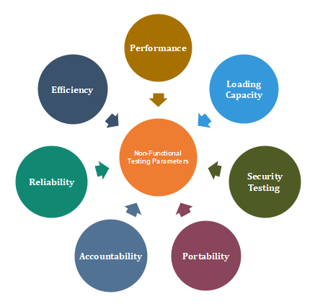
- Regression Testing
Definition:
Regression testing is performed after modifications to the software to ensure that existing functionalities remain unaffected.
Purpose:
To confirm that recent changes haven't introduced new bugs or broken existing features.
Key Considerations:
- Typically automated for efficiency.
- Should be part of the continuous integration/continuous deployment (CI/CD) pipeline.

Open Regression-Testing.jpg
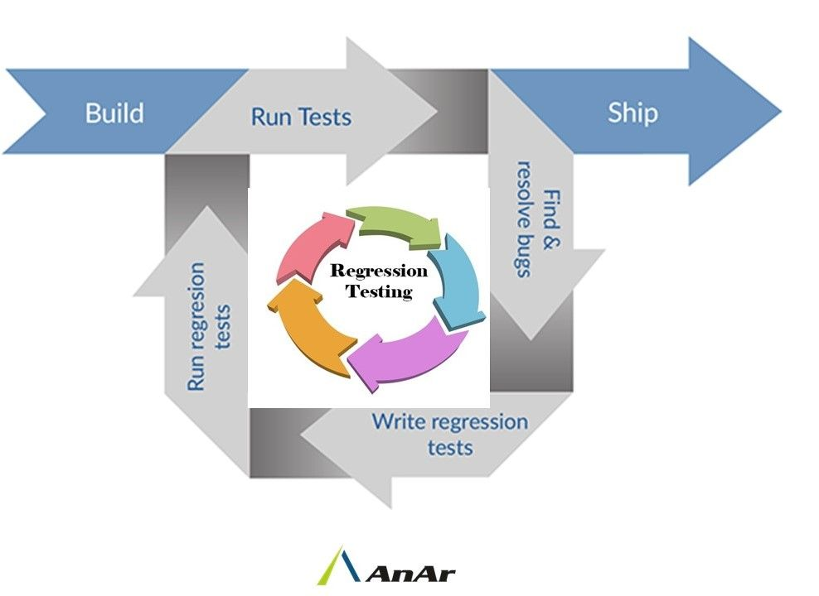

- Performance Testing
Definition:
Performance testing measures the speed, responsiveness, and stability of the software under various conditions.
Purpose:
To ensure the application performs well under expected and peak load conditions.
Key Considerations:
- Can include load testing, stress testing, and endurance testing.
- Aims to identify performance bottlenecks and ensure scalability.

Open Key Performance Indicator.png
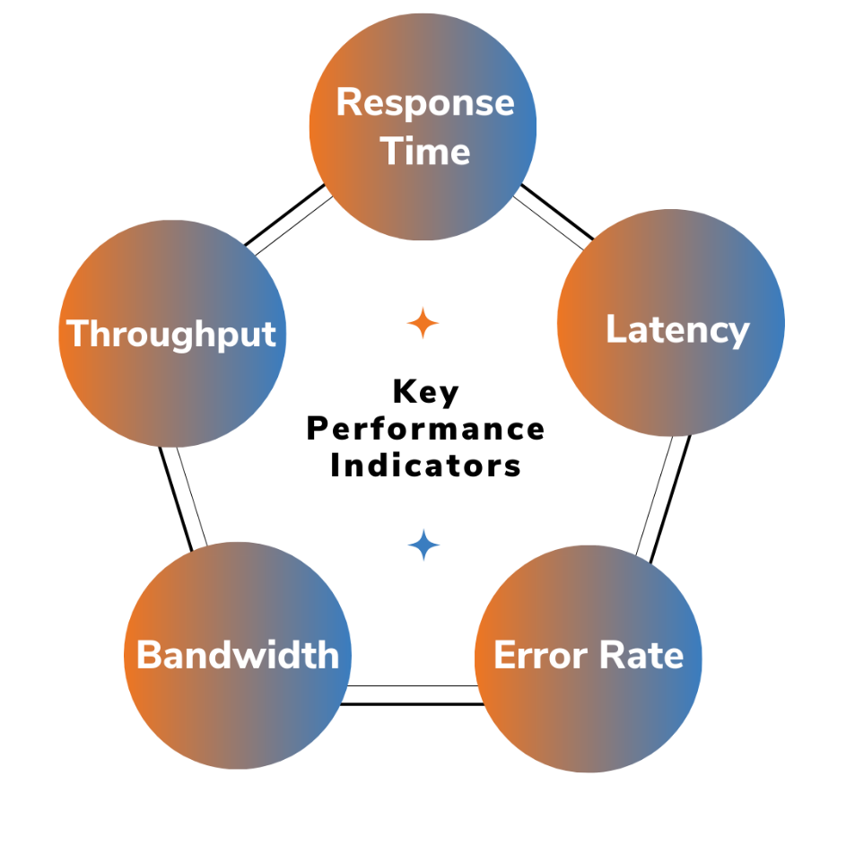

- Security Testing
Definition:
Security testing identifies vulnerabilities, threats, and risks in the software to ensure that data and resources are protected from possible intrusions.
Purpose:
To ensure the software is secure from external attacks and unauthorized access.
Key Considerations:
- Involves techniques like penetration testing and vulnerability scanning.
- Requires a strong understanding of security standards and best practices.
Open security-testing.png
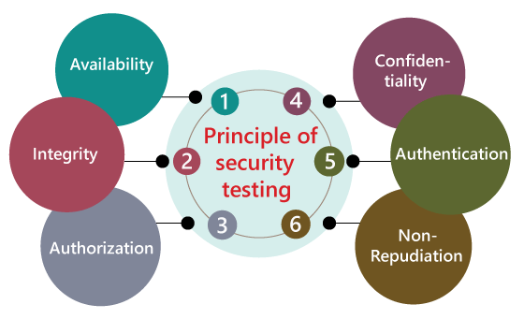

- Usability Testing
Definition:
Usability testing assesses how easy and user-friendly the software is for end-users. It focuses on the overall user experience.
Purpose:
To identify any usability issues and improve the user interface and user experience.
Key Considerations:
- Typically involves real users testing the software in a controlled environment.
- Feedback is gathered to make iterative improvements.

Open benefits-of-usability-testing.webp
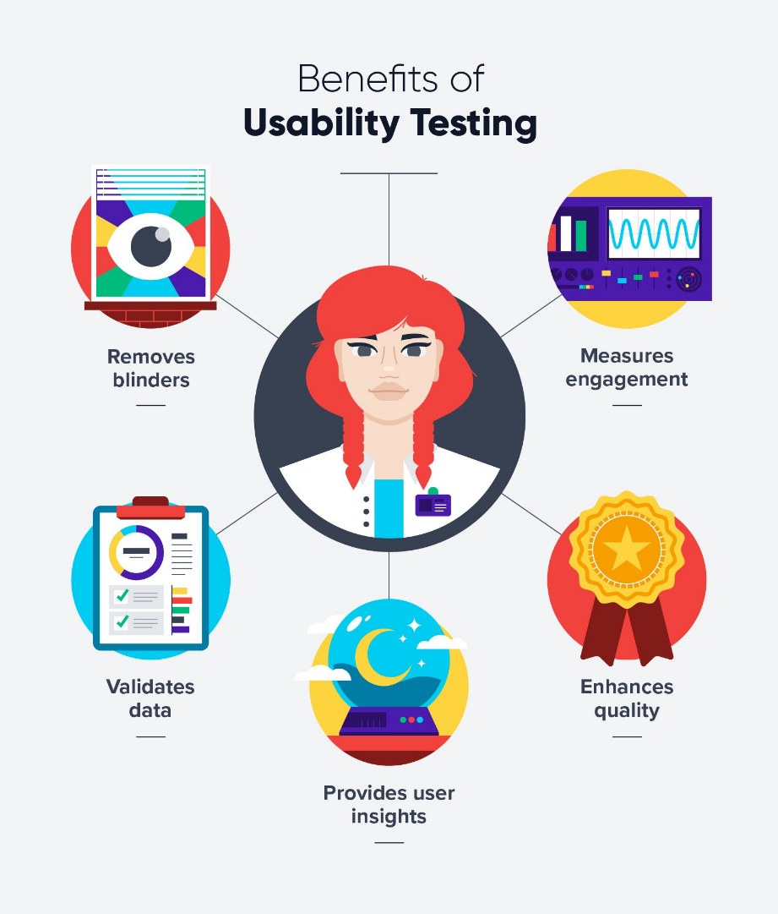
- Smoke Testing
Definition:
Smoke testing is a preliminary test to check the basic functionality of an application. It acts as a gatekeeper to ensure that the most critical functions work before proceeding with more detailed testing.
Purpose:
To verify that the major features of an application are functioning correctly and that the build is stable enough for further testing.
Key Considerations:
- Typically, automated and executed after a new build is deployed.
- Helps identify showstopper issues quickly.
- Also known as "build verification testing."

Open Smoke-Testing.png
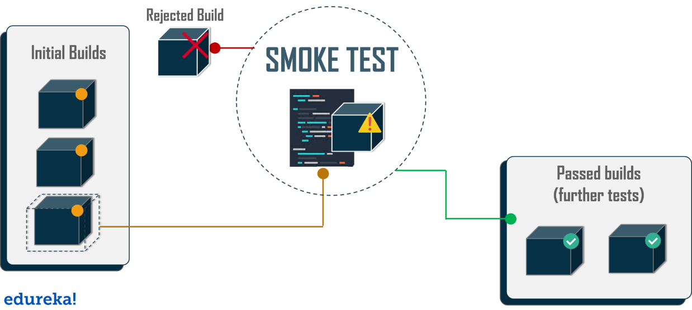

- Sanity Testing
Definition:
Sanity testing is a focused form of regression testing conducted to verify that specific functionalities are working after changes (like bug fixes or enhancements) have been made.
Purpose:
To confirm that the bugs have been fixed and that the changes have not adversely affected other parts of the application.
Key Considerations:
- Narrower than smoke testing, focusing on areas of the application.
- Often used to determine if a build is stable enough for further testing.
- Can be performed manually or automated, depending on the testing strategy.

Open SanityTesting.png
